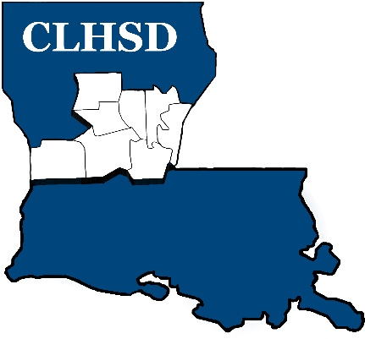

PUBLIC NOTICE
Meeting Cancellation

The Board of Directors of Central La Human Services District will not hold the April 2024 meeting due to lack of quorum.

We will be conducting board business at the next meeting, May 2nd at 5:30

